

MARANDA 2025 KCSE PREDICTION
EXPECTED EXAM 1
POWER MECHANICS
447/2
PAPER 2 (PRACTICAL)
TIME: 2½ HOURS

NAME……………………………………………………………………………………..
SCHOOL……………………………………………… SIGN………………………..
INDEX NO……………………………………………. ADM NO……………………

Kenya Certificate of Secondary Education.

Instructions to candidates
- Write your name and index number in the spaces provided above.
- Sign and write the date of examination in the spaces provided above.
(c) There are TEN stations in this examination.
(d) Candidates are allowed 15 minutes at each station
(e) At each station, candidates are not allowed to either review the previous stations’ work or read instruction for other stations
(f) Attempt ALL exercises in each station
(g) All dimensions are in millimeters unless otherwise stated.

For examiner’s use only
Stations | 1 | 2 | 3 | 4 | 5 | 6 | 7 | 8 | 9 | 10 | Total
Marks

STATION 1
INSTRUCTIONS:
The figure below shows a truncated air cleaner assembly. On the drawing paper (page 3) provided, sketch in good proportion the exploded view of the assembly and label four parts. (10 marks) a well-drawn exploded view with the following components: air cleaner cap, air intake tube, stud, air cleaner gasket ,vacuum motor, carburetor air cleaner, air cleaner element temperature sensor kit

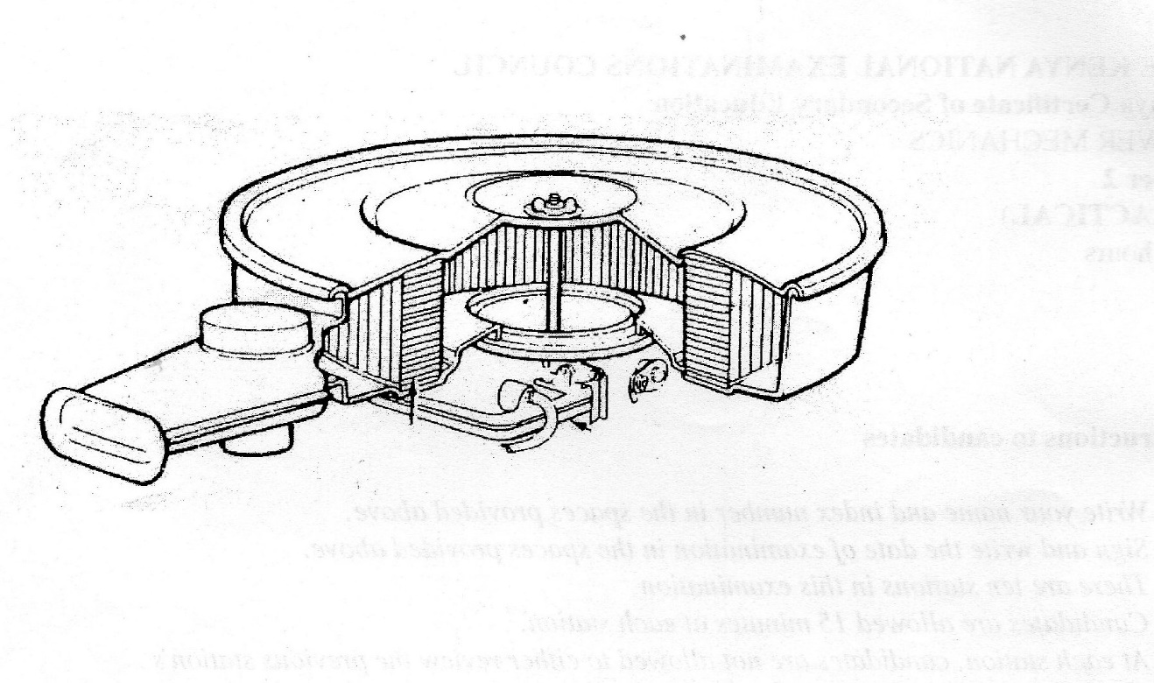

STATION 2

INSTRUCTIONS:
Draw an exploded view of the differential unit and label all the parts. (10 marks)
A well-drawn exploded view with the following parts:
-Shaft, axles ,side bevel gear, crown wheel, differential cage, and the pinion gear---10 marks

STATION 3

INSTRUCTIONS:

On the single cylinder engine provided;

- Remove the exhaust valve and show it to the examiner

- Reassemble the valve to its original position

- Measure and record the exhaust valve clearance.

....................................................

- Name the tool you have used to take the reading

....................................................... (10 marks )

Let the examiner check your work
The examiner to check the candidate work and award marks accordingly.
The examiner to check the candidate work and mark accordingly

STATION 4

(b) Identify the fasteners labelled P to T and state a feature that makes each fastener unique in its class. (5 marks)

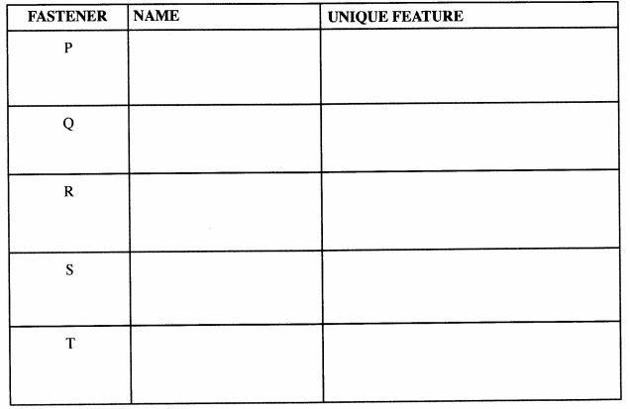

(10 marks)

STATION 5

INSTRUCTIONS:
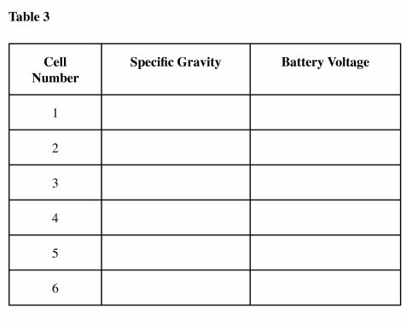

Identify two defects on the fan belt and state one possible cause of each defect; (10 marks)
(a) Measure and record the speciﬁc gravity and battery voltage of each cell in Table
3. (Take cell number l to be next to the positive terminal)
Table 3 (b) Check and comment on the state of:
(i) Battery electrolyte level
(ii) Battery charge
The examiner to check and award marks accordingly

STATION 6

INSTRUCTIONS:
On the engine provided, carry out the following tasks. (10 marks)
- Remove the rocker cover.
- Adjust the valve clearance for number 1to given specifications.
- Replace the rocker cover.
Let the examiner check your work.

Mark and award marks accordingly.

STATION 7
INSTRUCTIONS:

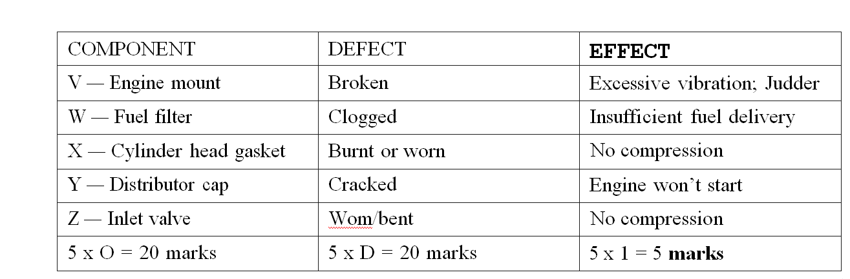

STATION 8

INSTRUCTIONS:

The figure 1 below shows 3 orthographic views of a block drawn in the first angle projection.
Draw the block FULL SIZE in isometric projection taking P as the lowest point. (10 marks)

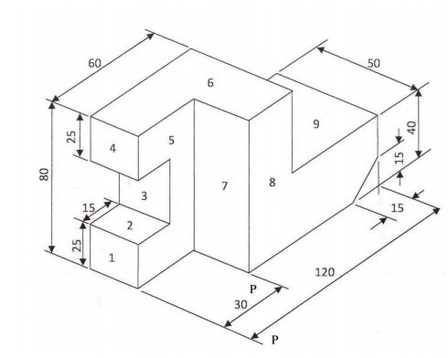

STATION 9

INSTRUCTIONS:
Using the instruments provided measure and record the readings in the table below.

PART | DESCRIPTION OF MEASUREMENT | MEASUREMENT TAKEN | NAME OF TOOL USED | ACCURACY OF TOOL USED
A | Cam height
B | Depth of blind hole
C | Intake valve margin
D | Taper
E | Pitch of spark plug

STATION 10
INSTRUCTIONS: using the tools and equipment provided make the scoop below.
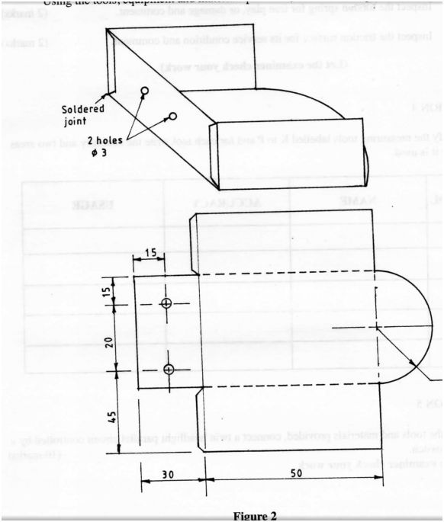
Award marks accordingly.

